|  |  |
| --- | --- |
|  | Research Document  **Front end: React vs Vue vs Angular** |
|  |  |
|  | by Radoslav Radev  ICT & Software Engineering semester 3  9/10/2022  ver. 1.2 |

1. Introduction

With hundreds of tools, libraries, and frameworks available, the JavaScript world is a rich ecosystem that is constantly expanding. The three most popular frameworks and libraries for creating user interfaces will be the subject of this research:

* React
* Vue
* Angular

1. Main question

Which Front End js framework is the best choice for my project?

1. Sub-Questions

* Which framework offers the most features?
* What framework is more widely used?
* Which framework is easier to learn?
* Which framework offers more documentation?

4: Choose methods

**Which framework offers the most features?**

According to <https://www.codeinwp.com/> framework that offers most native features is **Angular**, followed by **Vue** and then finally **React**. Angular offers features that other frameworks lack, such as:

* Routing
* Form Validation & Handling
* Http Client

These features are necessary for building web applications, features that are being imported as external libraries (modules or components) in **React** and **Vue**.

When it comes to importing external components libraries and frameworks, based on popularity, naturally there the most **React** third party libraries. Some of the most popular are:

* **Axios** – developers go to Http Client
* **Material Kit 2** – Material Ui design kit
* **Prime React** – Ui library kit
* **React Router** – Routing library

To give a summarization:

* Framework with most native features/libraries: **Angular**
* Framework with most third-party features/libraries: **React**



**What framework is more widely used?**

From publisher*:* [*https://plainenglish.io/*](https://plainenglish.io/)

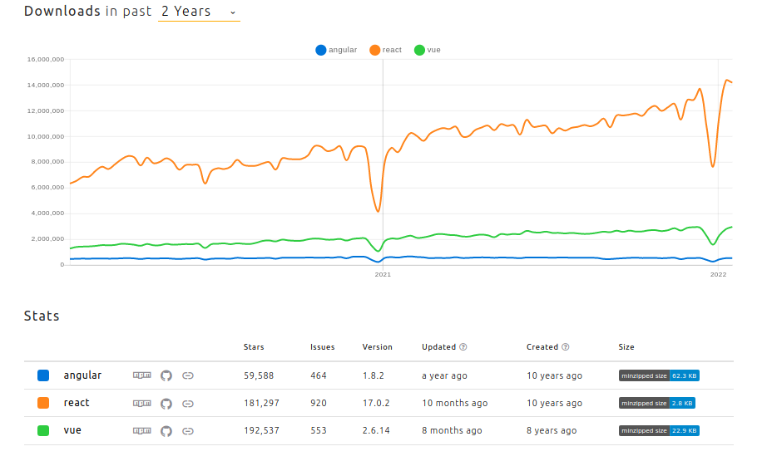

When it comes to popularity, JavaScript is a type of programming language that offers wide range of functionality and a plethora of development environments. While each and every framework offers unique features and benefits, when it comes to choosing a right framework for your application, any developers get consumed finding which one is more convenient and popular option to consider in the year 2022.

According to website [PlainEnglish](https://plainenglish.io/blog/angular-vs-react-vs-vue-js-which-is-the-best-choice-for-2022), the most popular framework for Single PageWeb development is **React**, followed by **Vue** and then finally **Angular**.

According to [NPM trends](https://npmtrends.com/angular-vs-react-vs-vue), React, Angular and View are the most downloaded JavaScript frameworks of 2022.

In todays world, nothing can be taken for granted. After a survey on [Stack Overflow](https://stackoverflow.com/), React leads the market with 35.9% of developers using it, meanwhile Angular is surpassing the popularity of Vue with 25.1% over 17.3%.

It is safe to say that the most popular JavaScript framework is **React**, with Angular and Vue fighting for the second place.

**Which framework is the easiest to learn?**

***React***

Made by Facebook in 2013, React doesn’t offer any mandatory project structure. Key feature of react is that is makes use of the infamous JSX syntax (JavaScript and XML), in other words a syntactic extension that enables the creation of components that simultaneously contain HTML and JavaScript. Components can be exported. This adds ease of use to the developer considering the reusability of components as well as simpleness and readability.

*An example of JSX syntax:*

Key features/advantages of React are:

* + Reusability
  + Simple debugging process
  + Migrations
  + View orientation
  + IOS and Android support
  + Support of React Native library (efficiency and performance boost)

**It is safe to say that out of all three previously mentioned framework, React is the simplest and easiest framework to learn.**

***Vue***

Vue was developed in 2014 by an ex Google employee, Evan You. It`s a framework used for creating user interfaces based on HTML, JavaScript and CSS. Like React, it offers a component based reusable programming approach that enables developers to create interactive UI for both simple and complex applications. Although it is slightly more difficult process to create a component in Vue.

*An example of Vue`s syntax:*

Some pros of Vue:

* + Simplicity
  + Simple integration
  + Customizability
  + Virtual DOM performance and rendering
  + Two-Way binding
  + Readability

**Vue has a slightly higher learning curve than React, but considering the lack of developers and learning resources, it can be hard to deal with in certain scenarios**

***Angular***

Developed by Google in 2010, angular is the oldest among two previously mentioned frameworks. Yet again, it is a reusable component based framework designed to build big scalable web applications. It provides a clear structure for developers to work with.

It offers features such as:

* + Cross platform
  + Uses TypeScript
  + Automatic code spelling
  + MVC architecture
  + Dependency injection
  + Animation API for high performance
  + Object orianted

It has its cons:

* + Complex and verbose (people tend to go away from it)
  + Limited SEO capabilities

*Example of Angular syntax.*

**Angular has a steep learning curve, with a weird JSX syntax. It is by far the hardest one of three.**

**Which framework offers more documentation?**

Recourses of React and Angular are significantly higher than Vue. Vue is a relatively newer framework with less community. It is only logical that it would be lacking learning resources. On the other hand, React and Angular have been here for a long time. In Angular`s and Reacts case, Stack Overflow offers much more answered questions than Vue. That’s simply due to them being the “Easiest” and “The Hardest” frameworks out of three. As already mentioned community behind Vue is smaller, but still big enough for a developer to find an answer to his problem.

5: Conclusion

React, Vue and Angular are undoubtably three most used, popular and beloved JavaScript frameworks. All of them have their pros and cons, but at the end of the day, all of them were developed to do the same thing, build single page web applications.

When taking into consideration the pros and cons of the framework, as well as the workflow, **React** is would be the framework of my choice.

It simply makes it painless to create interactive Uis. There is no structure in particular that one has to follow while creating the applications. That fits my personal preference.

The JSX syntax of React is unbelievably simple and readable. Besides that it offers countless external libraries/components to make development even easier!

At the end of the day, all of them are great at what they do. But watch out, Angular is scary.

**References**

Radoslav Radev (2022), *Angular vs React Vs Vue*,

My thoughts, [accademind.com](http://accademind.com/)

Sophia Martin (20/04/2022), *Angular vs React vs Vue.js: Which is the Better Choice for 2022 | JavaScript in Plain English*, [javascript.plainenglish.com](https://javascript.plainenglish.io/)

Itesh Sharma (16/04/2021), *What is Vue, pros and cons*, <https://www.tatvasoft.com/>

Shaumik Daityari (17/08/2022), *Angular vs React vs Vue.js: Which framework to choose*, <https://www.codeinwp.com>

Nihar Raval (19/10/2022), *Which framework to pick for front end development*, <https://radixweb.com/>